Practical 1 : Introduction to React and Component Architecture
Problem Definition :
- Create a React application using Vite for a student portfolio page.
- The application must include at least 4 reusable components: Header, About, Skills, and Footer.
- Each component must be independently structured and composed into a single-page layout.
- No logic or JSX should be duplicated across components.
- Props must be used to pass at least one piece of data into a minimum of 2 components.
Folder Structure :
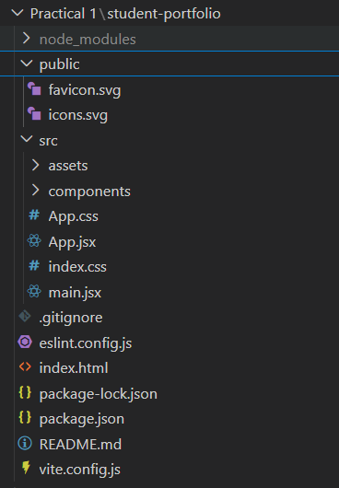

about.jsx :
function About() {
return (
<section className="section">
<h2>About Me</h2
<p>
my name is rudra and i am a student.
</p>
<div className="details">
<p><strong>College :</strong> DEPSTAR </p>
<p><strong>Subject :</strong> ITUE301 - ADVANCED WEB DEVELOPMENT FRAMEWORKS</p>
<p><strong>Semester :</strong>5th Sem</p>
<p><strong>Enrollment No :</strong> D25DIT081</p>
<p><strong>Division :</strong> 5IT </p>
</div>
</section>
);
}

export default About;

header.jsx :

function Header(props) {
return (
<section className="hero">
<h1 style={{ color: props.themeColor }}>{props.title}</h1>
<h2>{props.name}</h2>
<p>{props.role}</p>
<button>View Skills</button>
</section>
);
}

export default Header;

navbar.jsx:

function Navbar() {
return (
<nav className="navbar">
<h2 className="logo">Portfolio</h2>
<ul>
<li className="active">Home</li>
<li>About</li>
<li>Skills</li>
<li>Contact</li>
</ul>
</nav>
);
}

export default Navbar;

footer.jsx :

function Footer(props) {
return (
<section className="footer">
<h2>Contact</h2>
<p>Email : {props.email}</p>
<p>Phone : {props.phone}</p>
<p>City : {props.city}</p>
<hr />
<p>© 2026 Student Portfolio</p>
</section>
);
}

export default Footer;

skills.jsx :

function Skills(props) {
return (
<section className="section">
<h2>Technical Skills</h2>
<div className="skills">
{props.skillList.map((skill) => (
<span className="skill" key={skill}>
{skill}
</span>
))}
</div>
</section>
);
}

export default Skills;

App.jsx

import "./App.css";

import Header from "./components/Header";
import About from "./components/About";
import Skills from "./components/Skills";
import Footer from "./components/Footer";
import Navbar from "./components/Navbar";

function App() {

const skills = [
"HTML",
"CSS",
"JavaScript",
"React",
"Node js",
"Vite"
];

return (
<div>
<Navbar />

<Header
title="Student Portfolio"
name="Rudra Maiyariya"
role="Computer Engineering Student"
themeColor="#ffffff"

/>

<About />

<Skills skillList={skills} />

<Footer
email="rudra@email.com"
phone="+91 1234567891"
city="Porbandar"
/>

</div>
);
}

export default App;

index.css

body{
margin:0;
}

Main.jsx:
import { StrictMode } from 'react'
import { createRoot } from 'react-dom/client'
import './index.css'
import App from './App.jsx'

createRoot(document.getElementById('root')).render(
<StrictMode>
<App />
</StrictMode>,
)

Output:


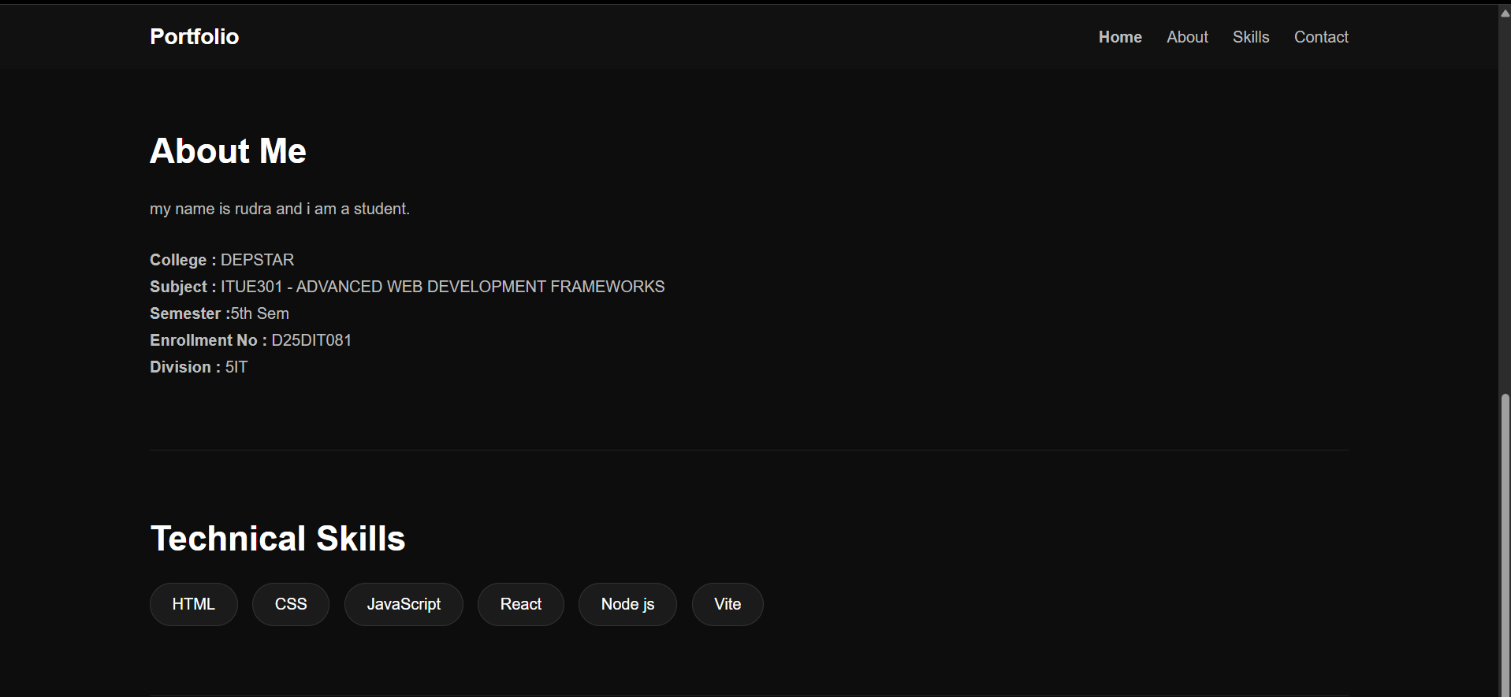
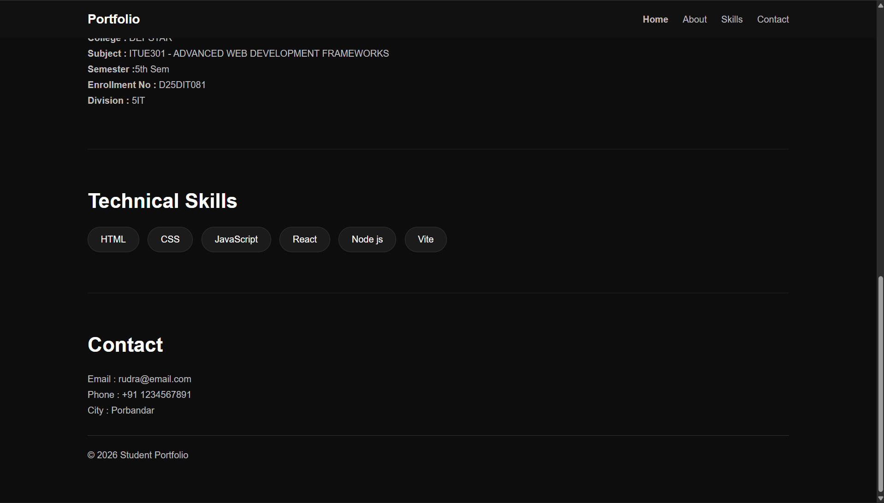

Supplementary Problems :
- Add a NavBar component that highlights the active section.

import React, { useState } from 'react';

function NavBar() {
const [active, setActive] = useState('Home');
const navItems = ['Home', 'About', 'Skills', 'Projects'];

return (
<nav style={{ display: 'flex', gap: '20px', padding: '20px', backgroundColor: '#f1f1f1' }}>
{navItems.map(item => (
<a
key={item}
href={`#${item.toLowerCase()}`}
onClick={() => setActive(item)}
style={{
fontWeight: active === item ? 'bold' : 'normal',
color: active === item ? '#0366d6' : '#333',
textDecoration: 'none'
}}
>
{item}
</a>
))}
</nav>
);
}
export default NavBar;

- Pass an array of skills as a prop to the Skills component and render them dynamically.

// Skills.jsx
import React from 'react';

function Skills({ skillsList }) {
return (
<section>
<h2>My Skills</h2>
<ul>
{skillsList.map((skill, index) => (
<li key={index}>{skill}</li>
))}
</ul>
</section>
);
}
export default Skills;

// Usage in App.jsx:
// <Skills skillsList={['HTML', 'CSS', 'JavaScript', 'React']} />

- Add a theme color prop to the Header and apply it as an inline style.\

// Header.jsx
import React from 'react';

function Header({ themeColor }) {
return (
<header style={{ backgroundColor: themeColor, padding: '20px', color: 'white' }}>
<h1>My Portfolio</h1>
</header>
);
}
export default Header;

// Usage in App.jsx:
// <Header themeColor="#282c34" />

Practical 2 : State Management and Routing in React

Problem Definition :
• Extend the portfolio application from Practical 1 by adding React Router.
• Implement a navigation bar with at least 3 routes: Home, Projects, and Contact.
• Each route must render a distinct component without a full page reload.
• Add at least 2 useState variables used meaningfully one for toggling UI visibility and one for managing a form input on the Contact page.
• The Contact page must include a controlled input that captures and displays user input in real time.
Folder Structure:
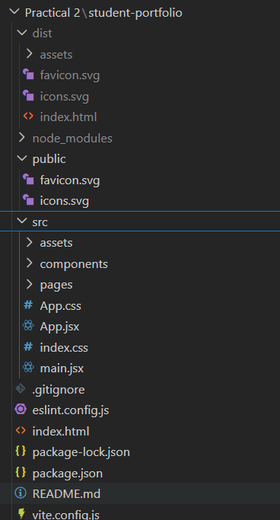
Code:

Index.html:

<!doctype html>
<html lang="en">
<head>
<meta charset="UTF-8" />
<link rel="icon" type="image/svg+xml" href="/favicon.svg" />
<meta name="viewport" content="width=device-width, initial-scale=1.0" />
<title>student-portfolio</title>
<script type="module" crossorigin src="/assets/index-wjLdS5mD.js"></script>
<link rel="stylesheet" crossorigin href="/assets/index-ClJC4mhn.css">
</head>
<body>
<div id="root"></div>
</body>
</html>

About.jsx:

function About() {
return (
<section className="section">
<h2>About Me</h2>
<p>
my name is rudra and i am a student.
</p>
<div className="details">
<p><strong>College :</strong> DEPSTAR </p>
<p><strong>Subject :</strong> ITUE301 - ADVANCED WEB DEVELOPMENT FRAMEWORKS</p>
<p><strong>Semester :</strong>5th Sem</p>
<p><strong>Enrollment No :</strong> D25DIT081</p>
<p><strong>Division :</strong> 5IT </p>
</div>
</section>
);
}

export default About;

Contact.jsx

import { useState } from "react";

function Contact() {
const [message, setMessage] = useState("");

return (
<section className="section">
<h2>Contact Page</h2>
<p>Send a message below and see real-time updates:</p>

<div className="details" style={{ marginTop: "25px" }}>
<label htmlFor="messageInput" style={{ display: "block", marginBottom: "10px", color: "#bdbdbd" }}>
Write Message:
</label>
<input
id="messageInput"
type="text"
value={message}
onChange={(e) => setMessage(e.target.value)}
placeholder="Type your message"
style={{
padding: "12px 20px",
width: "100%",
maxWidth: "450px",
borderRadius: "8px",
border: "1px solid #333",
background: "#1b1b1b",
color: "#fff",
fontSize: "16px",
outline: "none"
}}
/>

<div style={{ marginTop: "25px" }}>
<p><strong>Entered Text (Real Time):</strong></p>
<p style={{ color: "#fff", marginTop: "10px" }}>
{message || "No text entered yet..."}
</p>

<div style={{ marginTop: "15px" }}>
<p><strong>Character Count:</strong> {message.length}</p>
</div>
</div>

</div>
</section>
);
}

export default Contact;

Footer.jsx:

function Footer(props) {

return (

<section className="footer">

<h2>Contact</h2>

<p>Email : {props.email}</p>

<p>Phone : {props.phone}</p>

<p>City : {props.city}</p>

<hr />

<p>© 2026 Student Portfolio</p>

</section>

);

}

export default Footer;

Header.jsx:

function Header(props) {

return (

<section className="hero">

<h1 style={{ color: props.themeColor }}>{props.title}</h1>

<h2>{props.name}</h2>

<p>{props.role}</p>

<button>View Skills</button>

</section>

);

}

export default Header;

Home.jsx

import { useState } from "react";
import Header from "./Header";
import About from "./About";
import Skills from "./Skills";

function Home() {
const [showAbout, setShowAbout] = useState(true);

const skills = [
"HTML",
"CSS",
"JavaScript",
"React",
"Node js",
"Vite"
];

return (
<div>
<Header
title="Student Portfolio"
name="Rudra Maiyariya"
role="Computer Engineering Student"
themeColor="#ffffff"
/>

<div style={{ textAlign: "center", margin: "10px 0" }}>
<button onClick={() => setShowAbout(!showAbout)}>
{showAbout ? "Hide About Section" : "Show About Section"}
</button>
</div>

{showAbout && <About />}

<Skills skillList={skills} />
</div>
);
}

export default Home;

Navbar.jsx:

import { NavLink } from "react-router-dom";

function Navbar() {
return (
<nav className="navbar">

<h2 className="logo">Portfolio</h2>

<ul>

<li>
<NavLink to="/" className={({ isActive }) => (isActive ? "active" : "")}>
Home
</NavLink>
</li>

<li>
<NavLink to="/projects" className={({ isActive }) => (isActive ? "active" : "")}>
Projects
</NavLink>
</li>

<li>
<NavLink to="/contact" className={({ isActive }) => (isActive ? "active" : "")}>
Contact
</NavLink>
</li>

</ul>

</nav>
);
}

export default Navbar;

Project.jsx:

function Projects() {
return (
<section className="section">
<h2>My Projects</h2>
<div className="details">
<div style={{ marginBottom: "25px" }}>
<h3 style={{ fontSize: "22px", marginBottom: "8px" }}>Practical 1 - Portfolio Foundation</h3>
<p>Built the initial React portfolio application with reusable components (Header, About, Skills, Footer) and modern UI styling.</p>
</div>
<div style={{ marginBottom: "25px" }}>
<h3 style={{ fontSize: "22px", marginBottom: "8px" }}>Practical 2 - React Router & Hooks</h3>
<p>Extended the portfolio application with multi-page client-side routing using React Router and interactive state management with useState hooks.</p>
</div>
</div>
</section>
);
}

export default Projects;

Skill.jsx:

function Skills(props) {

return (

<section className="section">

<h2>Technical Skills</h2>

<div className="skills">

{props.skillList.map((skill) => (

<span className="skill" key={skill}>
{skill}
</span>

))}

</div>

</section>

);

}

export default Skills;

NotFound.jsx:

function NotFound() {
return (
<section className="section">
<h2>404 - Page Not Found</h2>
<p>The page you are looking for does not exist.</p>
</section>
);
}

export default NotFound;

App.jsx
import { BrowserRouter, Routes, Route } from "react-router-dom";
import "./App.css";

import Navbar from "./components/Navbar";
import Footer from "./components/Footer";
import Home from "./components/Home";
import Projects from "./components/Projects";
import Contact from "./components/Contact";
import NotFound from "./pages/NotFound";

function App() {
return (
<BrowserRouter>
<div>
<Navbar />

<Routes>
<Route path="/" element={<Home />} />
<Route path="/projects" element={<Projects />} />
<Route path="/contact" element={<Contact />} />
</Routes>

<Footer
email="rudra@email.com"
phone="+91 1234567891"
city="Porbandar"
/>
</div>
</BrowserRouter>
);
}

export default App;
Index.css:
body{
margin:0;
}
Main.jsx:

import { StrictMode } from 'react'
import { createRoot } from 'react-dom/client'
import './index.css'
import App from './App.jsx'

createRoot(document.getElementById('root')).render(
<StrictMode>
<App />
</StrictMode>,
)

Output:


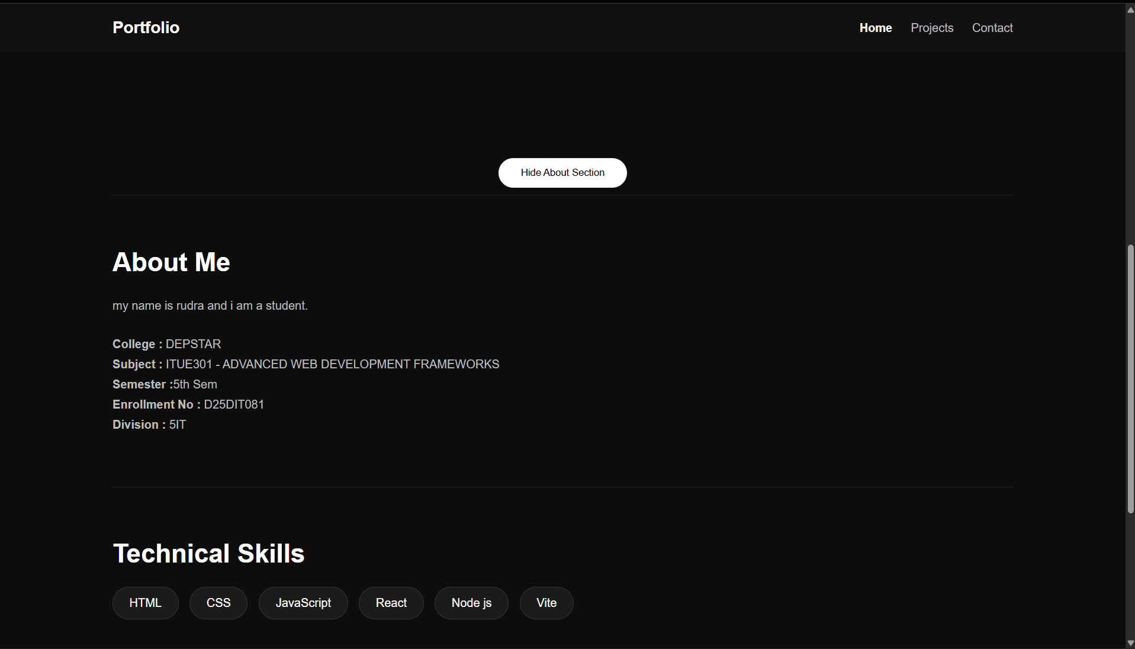

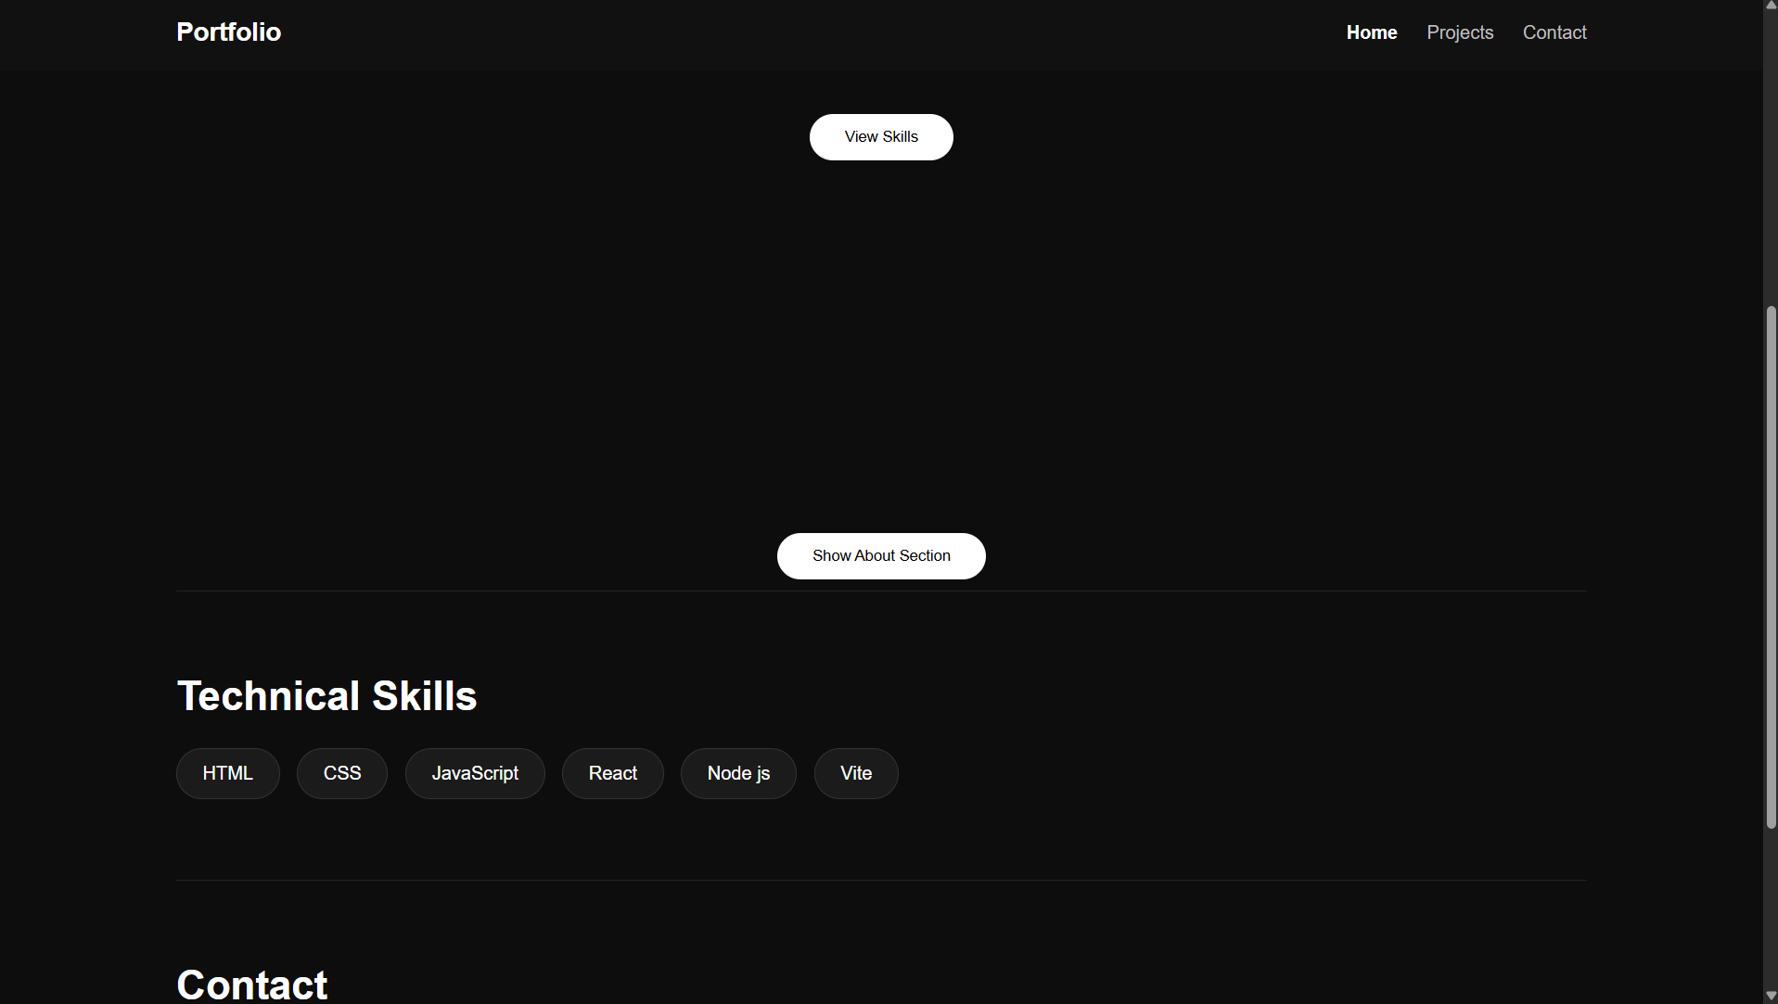

Project:

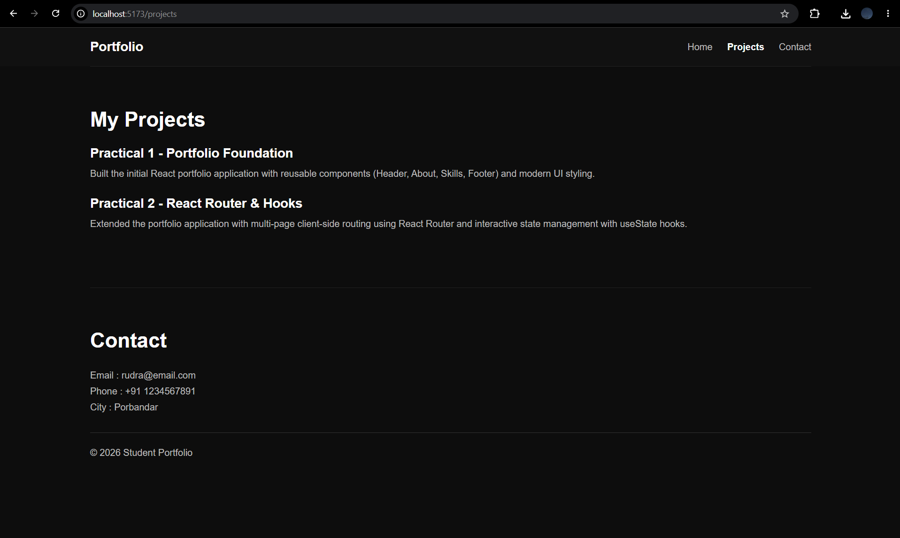

Contact:
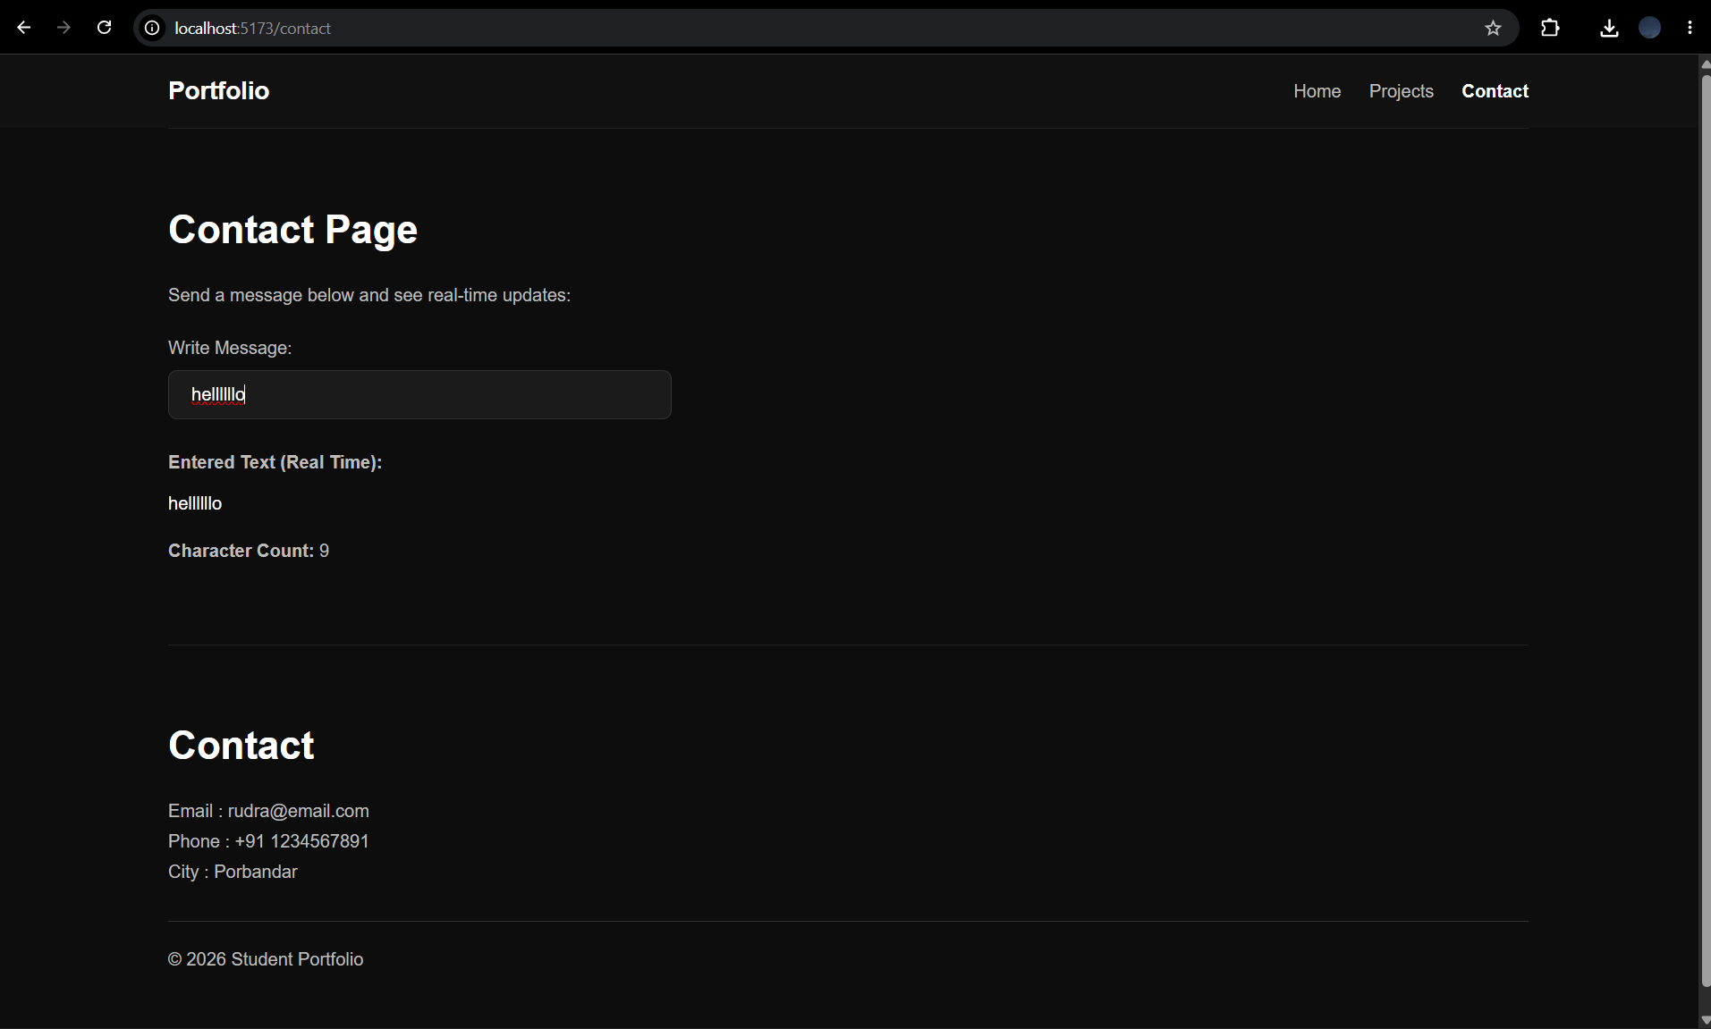

Supplementary Problems :
• Add a 404 Not Found route that renders a custom error component for unknown paths.

NotFound.jsx:
import React from 'react';
import { Link } from 'react-router-dom';

function NotFound() {
return (
<div style={{ textAlign: 'center', padding: '50px' }}>
<h2>404 - Page Not Found</h2>
<p>Oops! The page you are looking for does not exist.</p>
<Link to="/" style={{ color: 'blue', textDecoration: 'underline' }}>Go back to Home</Link>
</div>
);
}
export default NotFound;

App.jsx:
<Route path="*" element={<NotFound />} />

• Implement a dark/light mode toggle using useState that applies a CSS class to the root element.

App.jsx:
import React, { useState, useEffect } from 'react';

function App() {
const [isDarkMode, setIsDarkMode] = useState(false);

useEffect(() => {
// Toggles a CSS class on the root body element
if (isDarkMode) {
document.body.classList.add('dark-mode');
} else {
document.body.classList.remove('dark-mode');
}
}, [isDarkMode]);

return (
<div>
<button onClick={() => setIsDarkMode(!isDarkMode)}>
Switch to {isDarkMode ? 'Light' : 'Dark'} Mode
</button>
{/* Rest of the app components */}
</div>
);
}

• Store the contact form input in state and display a live character count below the input.

Contact.jsx:
import React, { useState } from 'react';

function Contact() {
const [message, setMessage] = useState('');

return (
<section>
<h2>Contact Me</h2>
<textarea
value={message}
onChange={(e) => setMessage(e.target.value)}
placeholder="Type your message..."
rows="5"
style={{ width: '100%' }}
/>
{/* Live character count display */}
<p style={{ color: '#555', fontSize: '14px' }}>
Character count: {message.length}
</p>
</section>
);
}
export default Contact;

Practical 3 : API Integration and Data Rendering in React

Problem Definition :
• Integrate a public REST API (e.g., GitHub API) into the portfolio application to fetch and display a list of repositories dynamically.
• Use the Projects page built in Practical 2 as the integration point.
• Implement a loading spinner component shown while the request is in progress.
• Implement an error message component shown if the API call fails.
• Render at least the repository name and URL for each item returned.

Folder Structure:

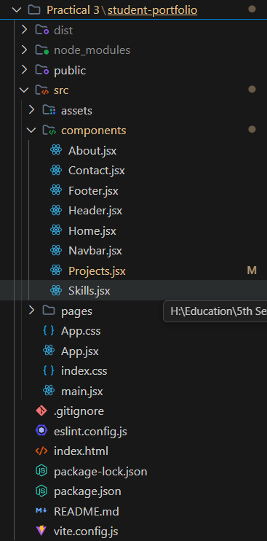

Code:
About.jsx:
function About() {

return (

<section className="section">

<h2>About Me</h2>

<p>
my name is rudra and i am a student.
</p>

<div className="details">

<p><strong>College :</strong> DEPSTAR </p>

<p><strong>Subject :</strong> ITUE301 - ADVANCED WEB DEVELOPMENT FRAMEWORKS</p>

<p><strong>Semester :</strong>5th Sem</p>

<p><strong>Enrollment No :</strong> D25DIT081</p>

<p><strong>Division :</strong> 5IT </p>

</div>

</section>

);

}

export default About;

Contact.jsx:
import { useState } from "react";

function Contact() {
const [message, setMessage] = useState("");

return (
<section className="section">
<h2>Contact Page</h2>
<p>Send a message below and see real-time updates:</p>

<div className="details" style={{ marginTop: "25px" }}>
<label htmlFor="messageInput" style={{ display: "block", marginBottom: "10px", color: "#bdbdbd" }}>
Write Message:
</label>
<input
id="messageInput"
type="text"
value={message}
onChange={(e) => setMessage(e.target.value)}
placeholder="Type your message"
style={{
padding: "12px 20px",
width: "100%",
maxWidth: "450px",
borderRadius: "8px",
border: "1px solid #333",
background: "#1b1b1b",
color: "#fff",
fontSize: "16px",
outline: "none"
}}
/>

<div style={{ marginTop: "25px" }}>
<p><strong>Entered Text (Real Time):</strong></p>
<p style={{ color: "#fff", marginTop: "10px" }}>
{message || "No text entered yet..."}
</p>

<div style={{ marginTop: "15px" }}>
<p><strong>Character Count:</strong> {message.length}</p>
</div>
</div>

</div>
</section>
);
}

export default Contact;

Footer.jsx:
function Footer(props) {

return (

<section className="footer">

<h2>Contact</h2>

<p>Email : {props.email}</p>

<p>Phone : {props.phone}</p>

<p>City : {props.city}</p>

<hr />

<p>© 2026 Student Portfolio</p>

</section>

);

}

export default Footer;

Header.jsx:
function Header(props) {

return (

<section className="hero">

<h1 style={{ color: props.themeColor }}>{props.title}</h1>

<h2>{props.name}</h2>

<p>{props.role}</p>

<button>View Skills</button>

</section>

);

}

export default Header;

Home.jsx:
import { useState } from "react";
import Header from "./Header";
import About from "./About";
import Skills from "./Skills";

function Home() {
const [showAbout, setShowAbout] = useState(true);

const skills = [
"HTML",
"CSS",
"JavaScript",
"React",
"Node js",
"Vite"
];

return (
<div>
<Header
title="Student Portfolio"
name="Rudra Maiyariya"
role="Computer Engineering Student"
themeColor="#ffffff"
/>

<div style={{ textAlign: "center", margin: "10px 0" }}>
<button onClick={() => setShowAbout(!showAbout)}>
{showAbout ? "Hide About Section" : "Show About Section"}
</button>
</div>

{showAbout && <About />}

<Skills skillList={skills} />
</div>
);
}

export default Home;

Navbar.jsx:
import { NavLink } from "react-router-dom";

function Navbar() {
return (
<nav className="navbar">

<h2 className="logo">Portfolio</h2>

<ul>

<li>
<NavLink to="/" className={({ isActive }) => (isActive ? "active" : "")}>
Home
</NavLink>
</li>

<li>
<NavLink to="/projects" className={({ isActive }) => (isActive ? "active" : "")}>
Projects
</NavLink>
</li>

<li>
<NavLink to="/contact" className={({ isActive }) => (isActive ? "active" : "")}>
Contact
</NavLink>
</li>

</ul>

</nav>
);
}

export default Navbar;

Project.jsx:
import React, { useState, useEffect } from 'react';

const Spinner = () => (
<div style={{ textAlign: 'center', padding: '20px' }}>
<div style={{
display: 'inline-block',
width: '40px',
height: '40px',
border: '4px solid rgba(0,0,0,0.1)',
borderRadius: '50%',
borderTopColor: '#3498db',
animation: 'spin 1s ease-in-out infinite'
}}></div>
<style>
{`
@keyframes spin {
to { transform: rotate(360deg); }
}
`}
</style>
<p>Loading repositories...</p>
</div>
);

const ErrorMessage = ({ message }) => (
<div style={{ color: 'red', textAlign: 'center', padding: '20px', backgroundColor: '#ffeaea', borderRadius: '5px' }}>
<h3>Failed to load repositories</h3>
<p>{message}</p>
</div>
);

function Projects() {
const [repos, setRepos] = useState([]);
const [loading, setLoading] = useState(true);
const [error, setError] = useState(null);

useEffect(() => {
fetch('https://api.github.com/users/RudraMaiyariya/repos?sort=updated&per_page=3')
.then((res) => {
if (!res.ok) {
throw new Error(`Error: ${res.status} ${res.statusText}`);
}
return res.json();
})
.then((data) => setRepos(data))
.catch((err) => setError(err.message))
.finally(() => setLoading(false));
}, []);

return (
<section className="section">
<h2>My Projects</h2>

{loading && <Spinner />}
{error && <ErrorMessage message={error} />}
{!loading && !error && (
<div className="details" style={{ display: 'grid', gridTemplateColumns: 'repeat(auto-fill, minmax(300px, 1fr))', gap: '20px' }}>
{repos.map((repo) => (
<div key={repo.id} style={{
padding: "20px",
border: "1px solid #ddd",
borderRadius: "8px",
boxShadow: "0 2px 4px rgba(0,0,0,0.1)",
backgroundColor: "#fff"
}}>
<h3 style={{ fontSize: "20px", marginBottom: "10px" }}>
<a href={repo.html_url} target="_blank" rel="noopener noreferrer" style={{ textDecoration: 'none', color: '#0366d6' }}>
{repo.name}
</a>
</h3>
<p style={{ color: '#586069', fontSize: '14px', marginBottom: '15px' }}>
{repo.description || 'No description available.'}
</p>
{/*
<div style={{ display: 'flex', gap: '15px', fontSize: '12px', color: '#586069' }}>
{repo.language && <span>🟡 {repo.language}</span>}
<span>⭐ {repo.stargazers_count}</span>
</div>
*/}
</div>
))}
</div>
)}
</section>
);
}

export default Projects;

Skill.jsx:
function Skills(props) {

return (

<section className="section">

<h2>Technical Skills</h2>

<div className="skills">

{props.skillList.map((skill) => (

<span className="skill" key={skill}>
{skill}
</span>

))}

</div>

</section>

);

}

export default Skills;

NotFound.jsx:
function NotFound() {
return (
<section className="section">
<h2>404 - Page Not Found</h2>
<p>The page you are looking for does not exist.</p>
</section>
);
}

export default NotFound;

App.jsx:
import { BrowserRouter, Routes, Route } from "react-router-dom";
import "./App.css";

import Navbar from "./components/Navbar";
import Footer from "./components/Footer";
import Home from "./components/Home";
import Projects from "./components/Projects";
import Contact from "./components/Contact";
import NotFound from "./pages/NotFound";

function App() {
return (
<BrowserRouter>
<div>
<Navbar />

<Routes>
<Route path="/" element={<Home />} />
<Route path="/projects" element={<Projects />} />
<Route path="/contact" element={<Contact />} />
</Routes>

<Footer
email="rudra@email.com"
phone="+91 1234567891"
city="Porbandar"
/>
</div>
</BrowserRouter>
);
}

export default App;

Main.jsx:
import { StrictMode } from 'react'
import { createRoot } from 'react-dom/client'
import './index.css'
import App from './App.jsx'

createRoot(document.getElementById('root')).render(
<StrictMode>
<App />
</StrictMode>,
)

Output:
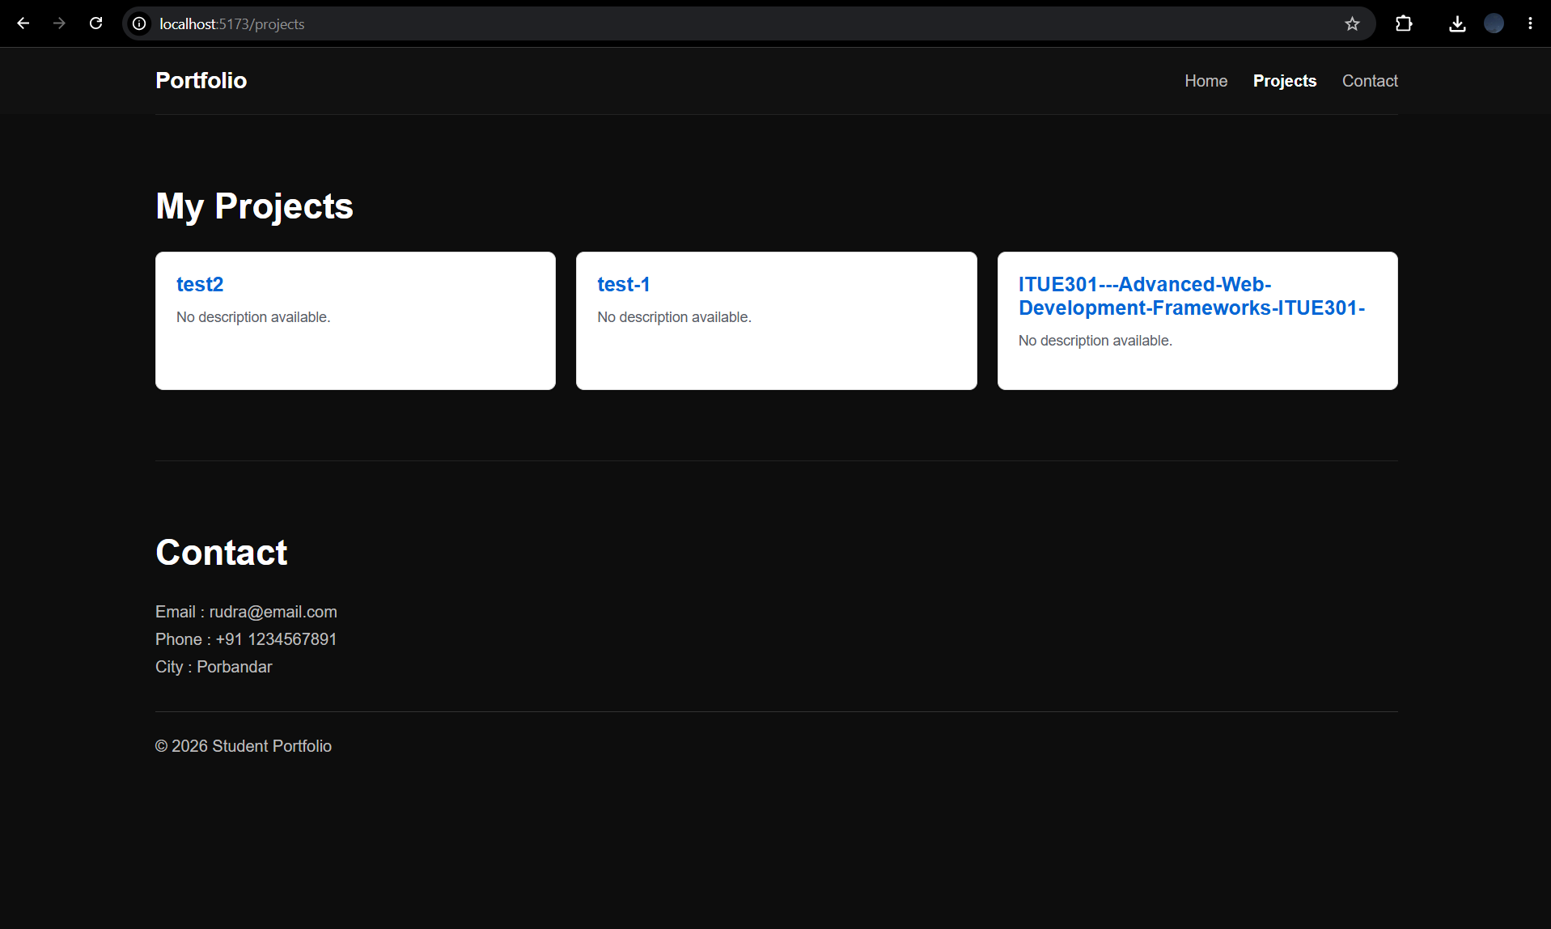

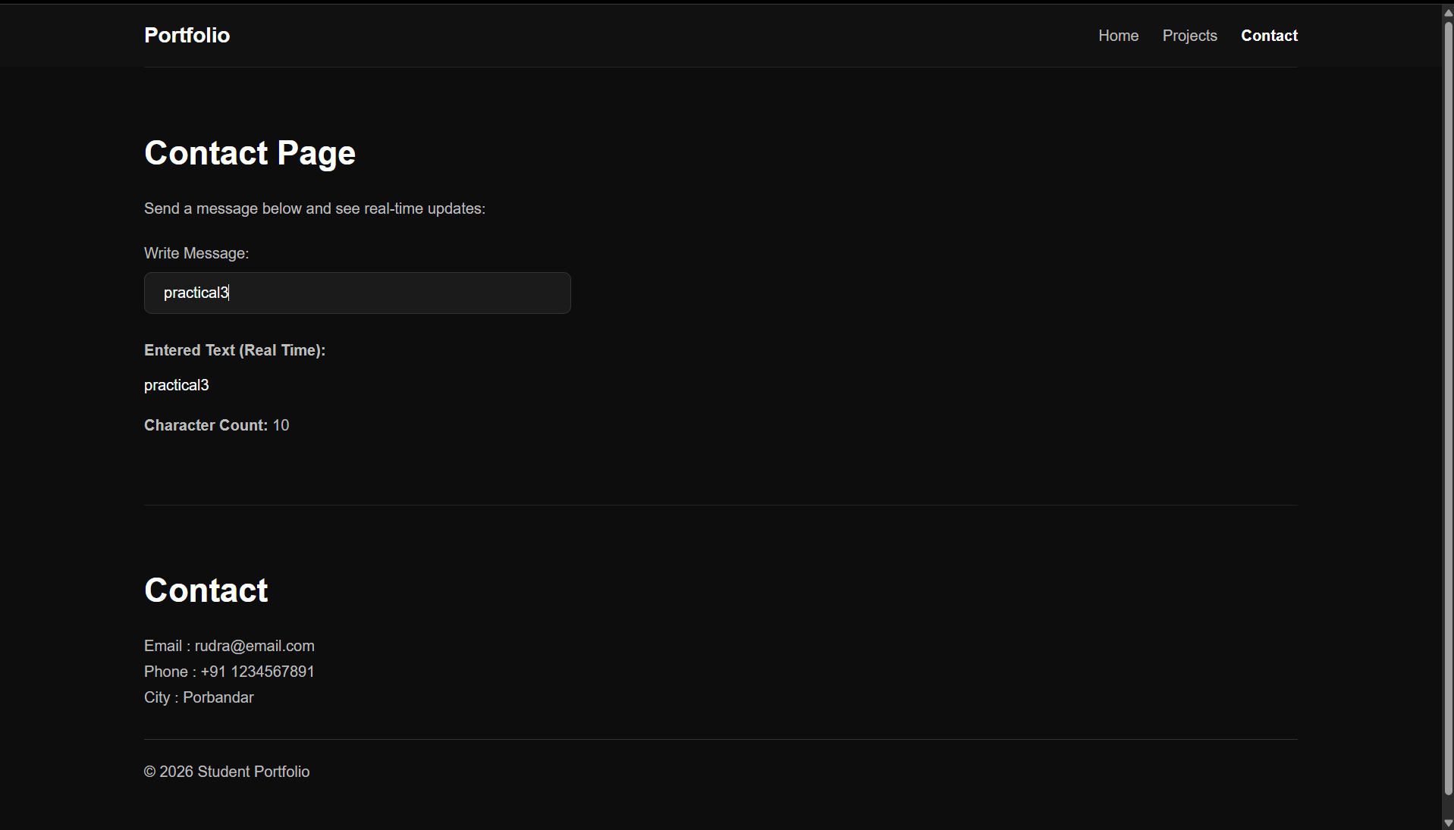

Supplementary Problems :

• Add a retry button that re-triggers the fetch when an error occurs.
• Add a search input that filters the rendered repository list by name.
• Display the repository's star count alongside its name.

import React, { useState, useEffect } from 'react';

function Projects() {
const [repos, setRepos] = useState([]);
const [loading, setLoading] = useState(true);
const [error, setError] = useState(null);

// Supplementary: Search and Retry state
const [searchTerm, setSearchTerm] = useState('');
const [retryCount, setRetryCount] = useState(0);

useEffect(() => {
setLoading(true);
setError(null);

fetch('https://api.github.com/users/RudraMaiyariya/repos')
.then((res) => {
if (!res.ok) throw new Error(`Error: ${res.status}`);
return res.json();
})
.then((data) => setRepos(data))
.catch((err) => setError(err.message))
.finally(() => setLoading(false));

// Adding retryCount to the dependency array makes it re-fetch when the retry button is clicked
}, [retryCount]);

// Supplementary: Filter the list based on the search input
const filteredRepos = repos.filter(repo =>
repo.name.toLowerCase().includes(searchTerm.toLowerCase())
);

return (
<section className="section">
<h2>My Projects</h2>

{/* Supplementary: Search Input */}
<input
type="text"
placeholder="Search repositories..."
value={searchTerm}
onChange={(e) => setSearchTerm(e.target.value)}
style={{ padding: '8px', marginBottom: '20px', width: '300px' }}
/>

{loading && <Spinner />}

{error && (
<div>
<ErrorMessage message={error} />
{/* Supplementary: Retry Button */}
<button
onClick={() => setRetryCount(prev => prev + 1)}
style={{ padding: '10px', marginTop: '10px', cursor: 'pointer' }}
>
Try Again
</button>
</div>
)}

{!loading && !error && (
<div className="details" style={{ display: 'grid', gridTemplateColumns: 'repeat(auto-fill, minmax(300px, 1fr))', gap: '20px' }}>
{filteredRepos.map((repo) => (
<div key={repo.id} style={{ padding: "20px", border: "1px solid #ddd", borderRadius: "8px" }}>
<h3><a href={repo.html_url}>{repo.name}</a></h3>

{/* Supplementary: Display star count */}
<p style={{ marginTop: '10px' }}>⭐ Stars: {repo.stargazers_count}</p>
</div>
))}
</div>
)}
</section>
);
}

export default Projects;

Practical 4 : Building a RESTful API with Node.js and Express

Problem Definition :
• Build a Node/Express backend for a Task Management system.
• Implement REST endpoints for creating, reading, updating, and deleting tasks (in-memory array, no database yet).
• Apply a request logging middleware that logs method, URL, and timestamp for every incoming request.
• Apply a global error handling middleware as the last middleware in the pipeline.
• Use correct HTTP status codes (200, 201, 404, 500) for each response.

Folder Structure:

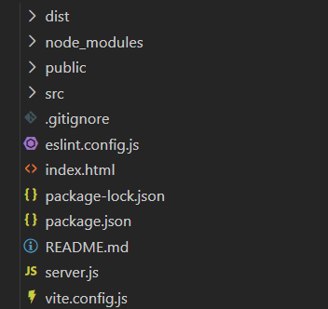

Code:
Server.js

import express from 'express';

const app = express();
const PORT = 5000;

// Step 2: Built-in Middleware to parse JSON bodies
app.use(express.json());

// Step 3: Request logging middleware applied globally
app.use((req, res, next) => {
console.log(`${req.method} ${req.url} - ${new Date().toISOString()}`);
next();
});

// SUPPLEMENTARY PROBLEM 1: Content-Type Validation Middleware
// Rejects POST/PUT requests without Content-Type: application/json
const checkContentType = (req, res, next) => {
if (['POST', 'PUT'].includes(req.method)) {
const contentType = req.headers['content-type'];
if (!contentType || !contentType.includes('application/json')) {
return res.status(400).json({
error: 'Bad Request: Content-Type header must be application/json'
});
}
}
next();
};

app.use(checkContentType);

// SUPPLEMENTARY PROBLEM 2: Route-Specific Task ID Validation Middleware
// Validates ID format before reaching controller
const validateTaskId = (req, res, next) => {
const id = Number(req.params.id);
if (!Number.isInteger(id) || id <= 0) {
return res.status(400).json({
error: 'Invalid Task ID format. Task ID must be a positive integer.'
});
}
req.taskId = id;
next();
};

// Step 4: In-memory array for task storage
let tasks = [
{ id: 1, title: 'Complete Practical 4', description: 'Build Node/Express REST API', completed: true },
{ id: 2, title: 'Submit Assignment', description: 'Test API with Postman', completed: false }
];
let nextId = 3;

// Root Route
app.get('/', (req, res) => {
res.json({ message: 'Task Management API is running. Use /tasks to access endpoints.' });
});

// CRUD Endpoint 1: GET /tasks (Read All Tasks)
app.get('/tasks', (req, res) => {
res.status(200).json(tasks);
});

// CRUD Endpoint 2: GET /tasks/:id (Read Task by ID with route-specific ID validation)
app.get('/tasks/:id', validateTaskId, (req, res) => {
const task = tasks.find(t => t.id === req.taskId);

if (!task) {
return res.status(404).json({ error: 'Task not found' });
}

res.status(200).json(task);
});

// CRUD Endpoint 3: POST /tasks (Create Task)
app.post('/tasks', (req, res) => {
const { title, description, completed } = req.body;

if (!title || title.trim() === '') {
return res.status(400).json({ error: 'Title is required' });
}

const newTask = {
id: nextId++,
title: title.trim(),
description: description || '',
completed: completed || false
};

tasks.push(newTask);
res.status(201).json(newTask);
});

// CRUD Endpoint 4: PUT /tasks/:id (Update Task with route-specific ID validation)
app.put('/tasks/:id', validateTaskId, (req, res) => {
const task = tasks.find(t => t.id === req.taskId);

if (!task) {
return res.status(404).json({ error: 'Task not found' });
}

const { title, description, completed } = req.body;
if (title !== undefined) task.title = title;
if (description !== undefined) task.description = description;
if (completed !== undefined) task.completed = completed;

res.status(200).json(task);
});

// CRUD Endpoint 5: DELETE /tasks/:id (Delete Task with route-specific ID validation)
app.delete('/tasks/:id', validateTaskId, (req, res) => {
const taskIndex = tasks.findIndex(t => t.id === req.taskId);

if (taskIndex === -1) {
return res.status(404).json({ error: 'Task not found' });
}

const deletedTask = tasks.splice(taskIndex, 1)[0];
res.status(200).json({ message: 'Task deleted successfully', task: deletedTask });
});

// Test Route to simulate error for Global Error Handler
app.get('/error-test', (req, res, next) => {
const err = new Error('Test server error');
next(err);
});

// SUPPLEMENTARY PROBLEM 3: Structured 404 Handler for Undefined Routes
app.use((req, res, next) => {
res.status(404).json({
success: false,
error: 'Route Not Found',
message: `The endpoint ${req.method} ${req.url} does not exist.`
});
});

// Step 5: Global error handling middleware (MUST be defined last)
app.use((err, req, res, next) => {
console.error(err.stack);
res.status(500).json({ error: 'Something went wrong', details: err.message });
});

// Start Server on Port 5000
app.listen(PORT, () => {
console.log(`Server running on port ${PORT}`);
});

Output:
Test: GET All Tasks (GET /tasks)
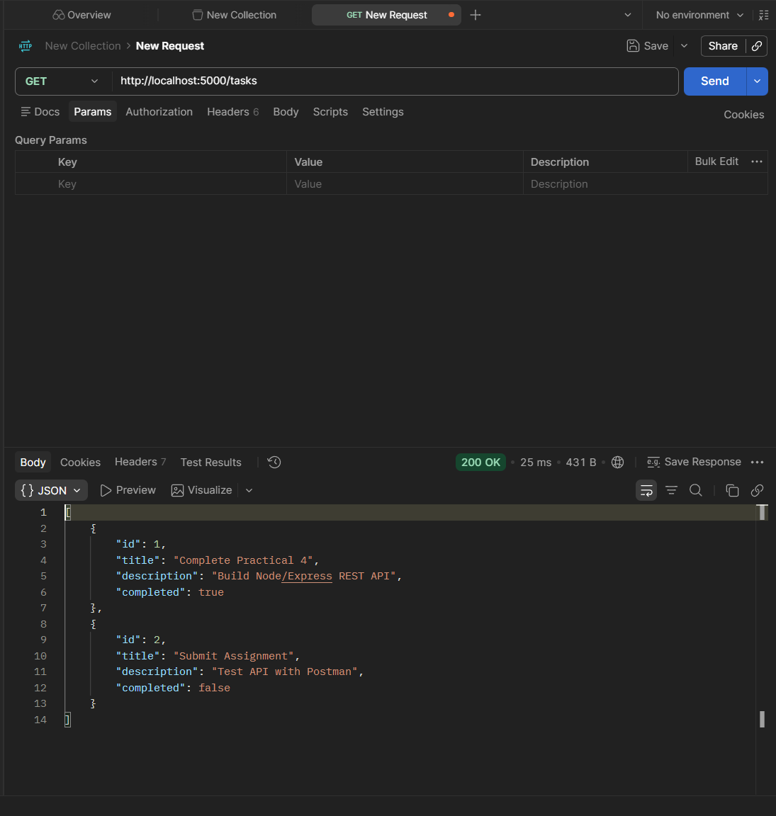

Test: GET Task By ID (GET /tasks/1)
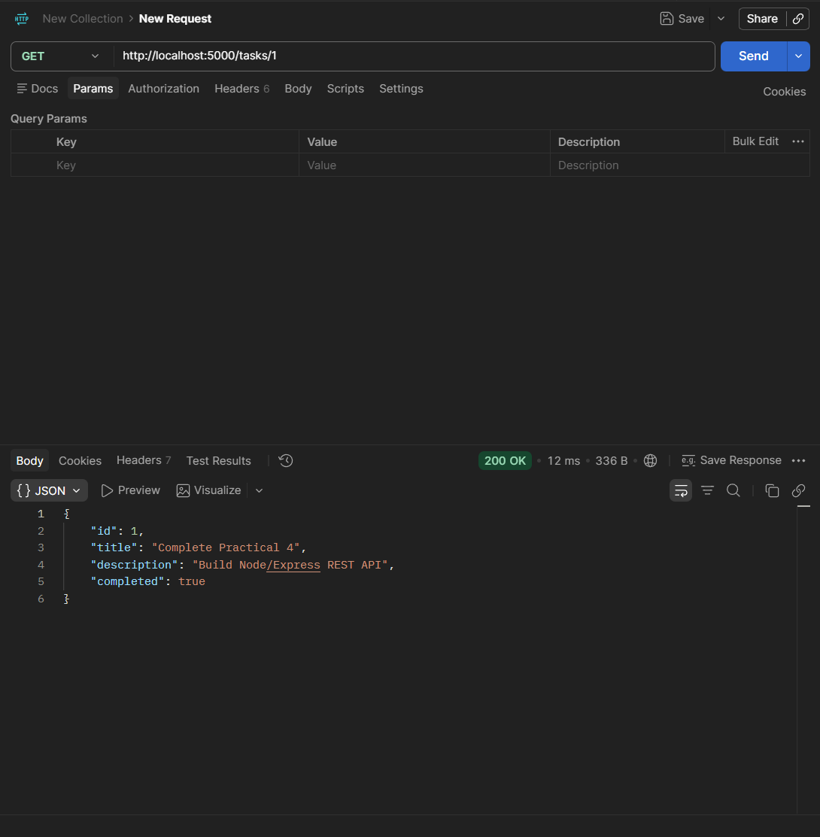

Test: Create New Task (POST /tasks)

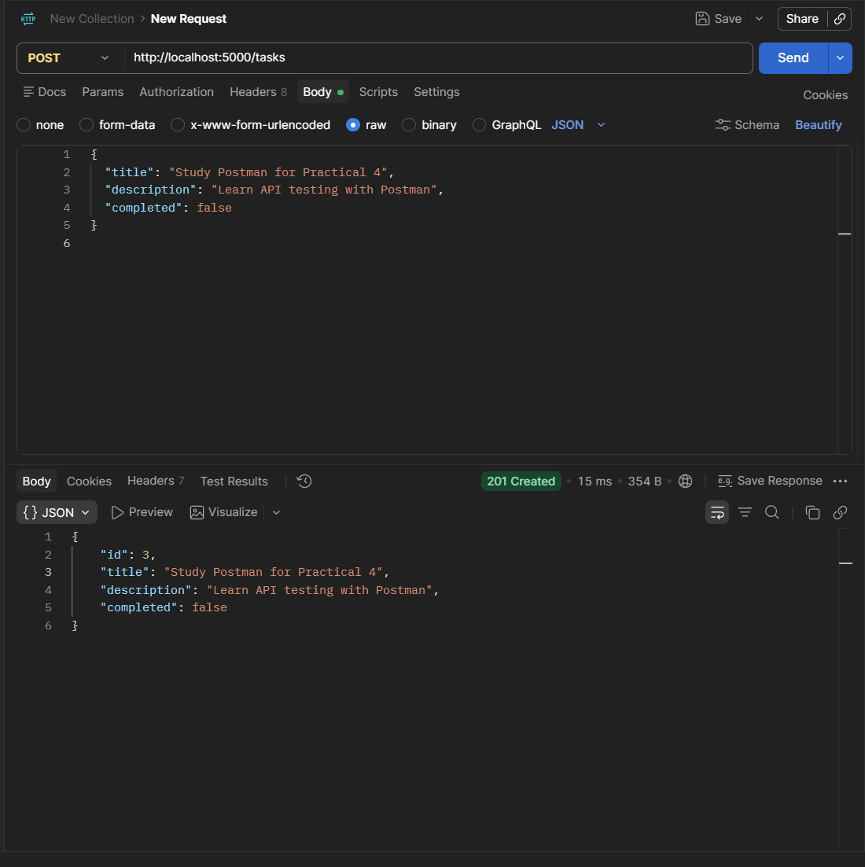

Test: Update Task (PUT /tasks/1)

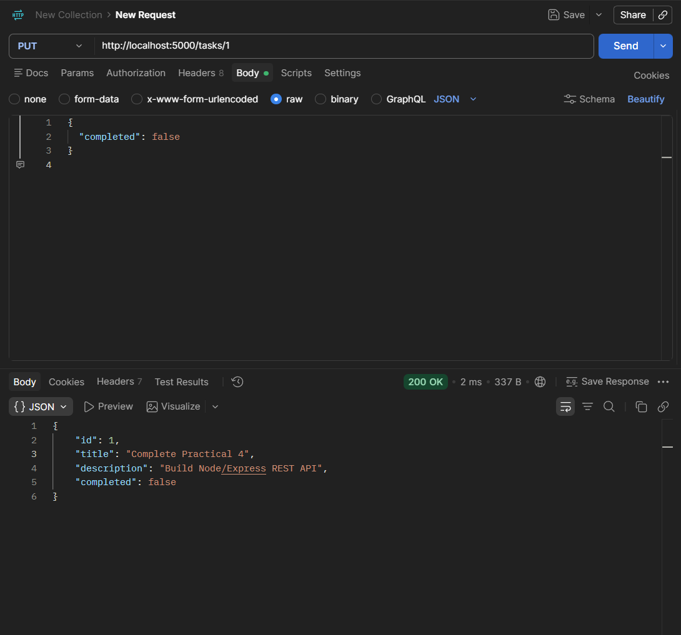

Test: Delete Task (DELETE /tasks/2)

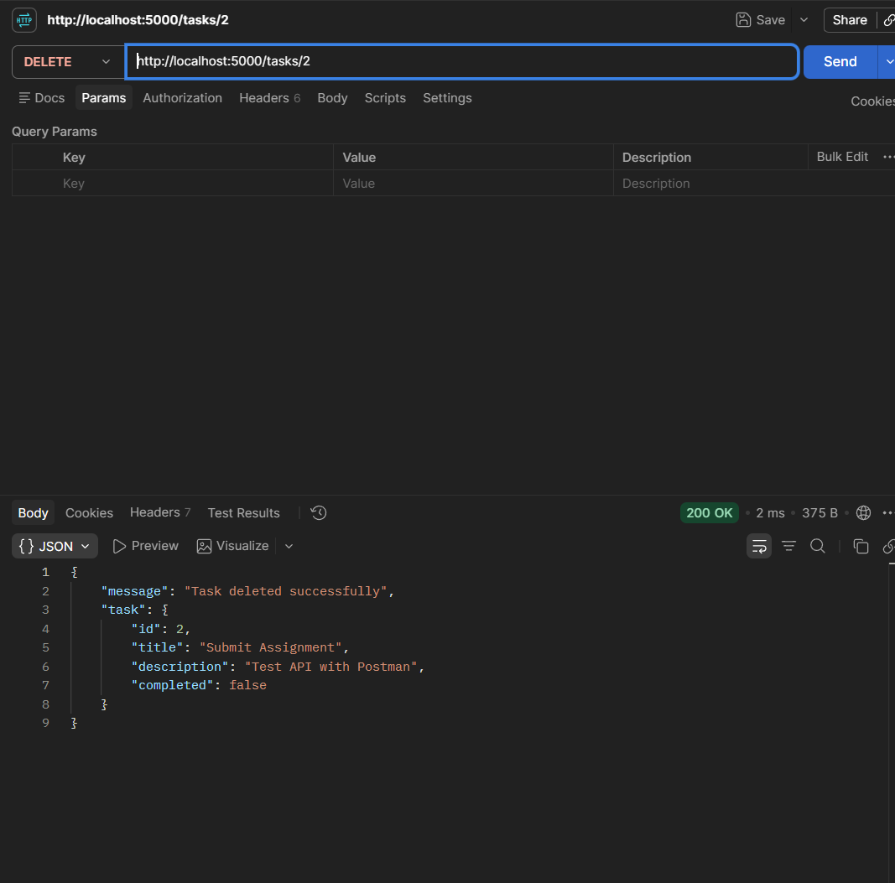

Test: Global Error Handling Middleware
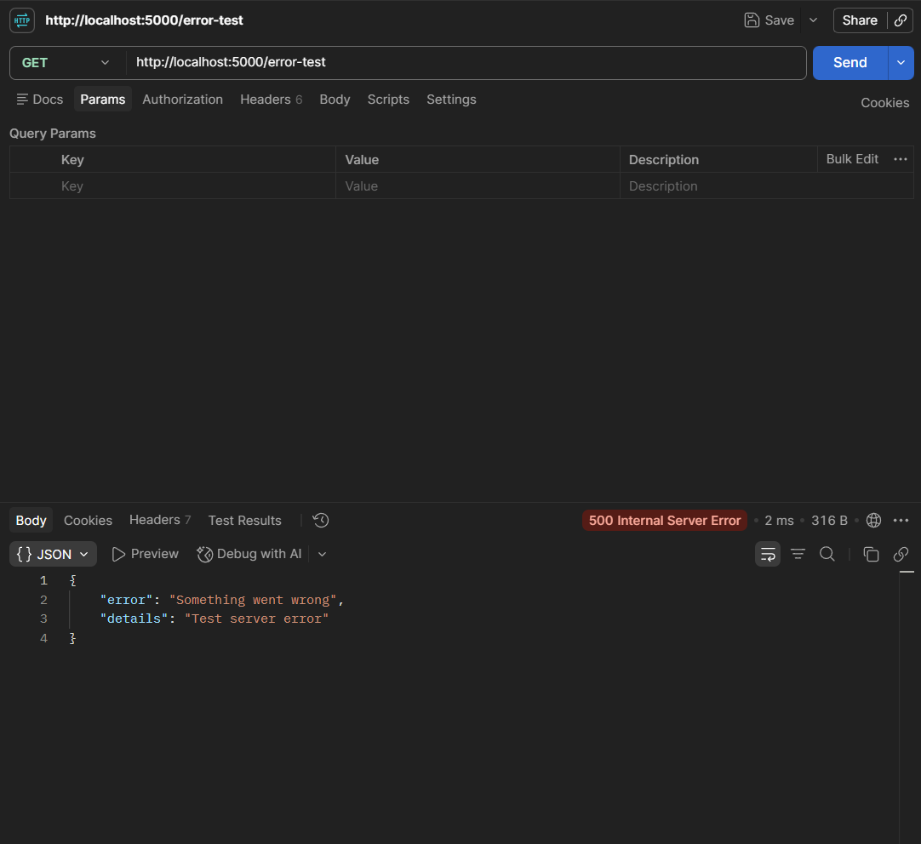

Supplementary Problems :

Question 1: Add a middleware that rejects requests without a Content-Type: application/json header on POST/PUT.
Code:
Server.js
const checkContentType = (req, res, next) => {
if (['POST', 'PUT'].includes(req.method)) {
const contentType = req.headers['content-type'];
if (!contentType || !contentType.includes('application/json')) {
return res.status(400).json({
error: 'Bad Request: Content-Type header must be application/json'
});
}
}
next();
};

app.use(checkContentType);

Output:

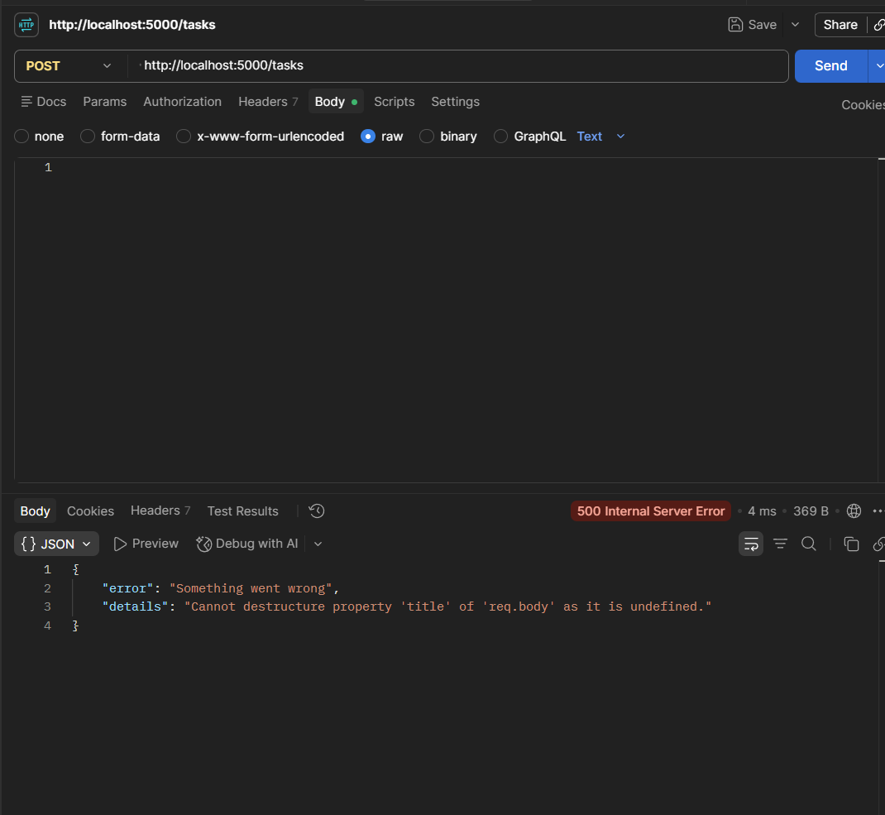

Question 2: Add a route-specific middleware that validates the task ID format before reaching the controller.

Code:

const validateTaskId = (req, res, next) => {
const id = Number(req.params.id);

if (!Number.isInteger(id) || id <= 0) {
return res.status(400).json({
error: 'Invalid Task ID format. Task ID must be a positive integer.'
});
}

req.taskId = id;
next();
};

app.get('/tasks/:id', validateTaskId, (req, res) => {
const task = tasks.find(t => t.id === req.taskId);
if (!task) return res.status(404).json({ error: 'Task not found' });
res.status(200).json(task);
});

Output:

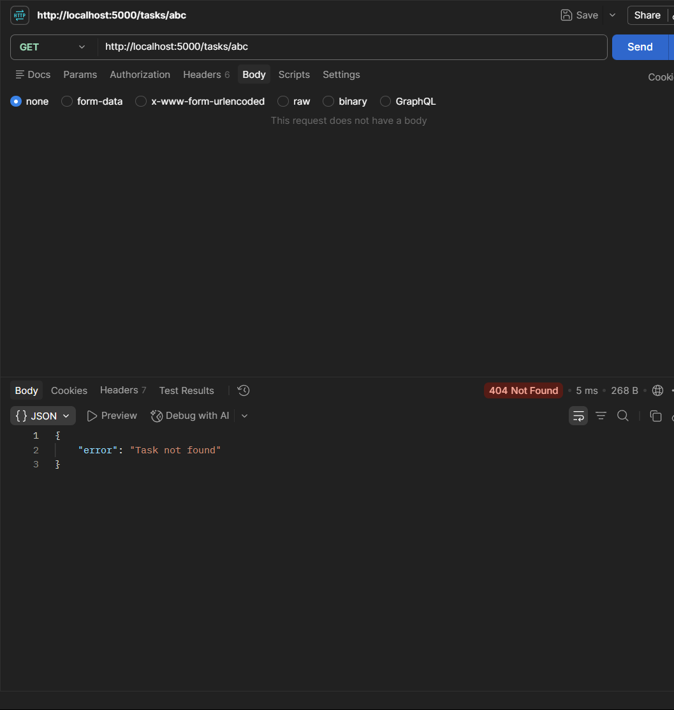

Question 3: Add a 404 handler for undefined routes that returns a structured JSON response.
Code:

app.use((req, res, next) => {
res.status(404).json({
success: false,
error: 'Route Not Found',
message: `The requested endpoint ${req.method} ${req.url} does not exist.`
});
});
Output:

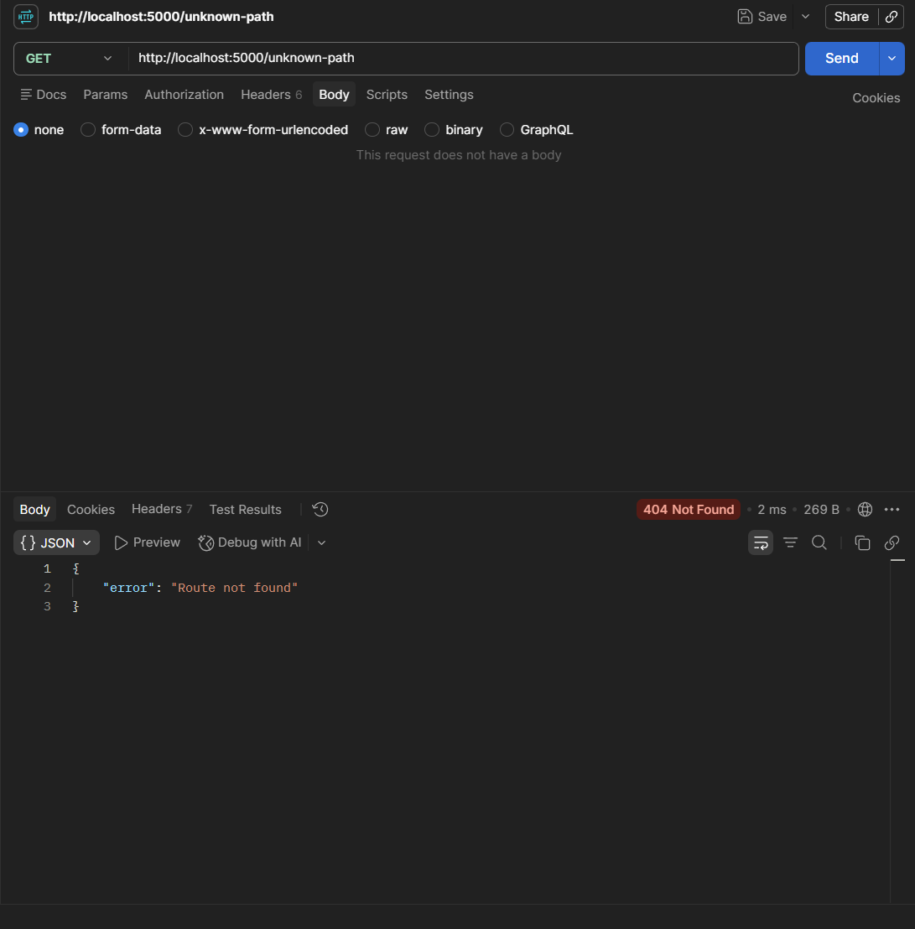

Practical 5: MongoDB Integration and Schema Design with Mongoose

Problem Definition :
• Extend the Task Management backend from Practical 4 by connecting MongoDB using Mongoose.
• Define a Task schema with at least 4 fields: title (String, required), description (String), completed (Boolean, default false), createdAt (Date, default Date.now).
• Replace the in-memory array from Practical 4 with real Mongoose model operations.
• Test all CRUD operations against the live database using Postman.
• Ensure validation errors are returned as structured JSON, not raw Mongoose error objects.

Folder Structure:
Code:
Output:

Supplementary Problems :

Question 1: Add a priority field to the schema restricted to an enum of ['low', 'medium', 'high'].
Code:
Output:

Question 2: Add a pre-save hook that automatically trims whitespace from the title field.

Code:
Output:
Question 3: Implement a GET /tasks/:id endpoint that returns a 404 JSON response if the ID does not exist.
Code:
Output:

Practical 6 : Full Stack Integration React + Node + MongoDB

Problem Definition :
• Connect the React Task UI to the Node+MongoDB backend built in Practicals 4 and 5.
• Replace the GitHub repo data from Practical 3 with task data from your own backend.
• The application must support creating, viewing, updating, and deleting tasks from the React interface through API calls.
• All data must be persisted in MongoDB confirmed by refreshing the browser and seeing data remain.
• Handle loading and error states for every API interaction, not just the initial fetch.

Folder Structure:
Code:
Output:

Supplementary Problems :

Question 1: Add an optimistic UI update for task creation show the new task in the list immediately, before the server confirms.

Code:
Output:

Question 2: Add a confirmation dialog before deleting a task.

Code:
Output:

Question 3: Add a toast/notification component that shows success or failure after each operation.
Code:
Output:

Practical 7 : Authentication and Middleware Pipeline

Problem Definition :
• Add user registration and login functionality to the Task Management application.
• Hash passwords using bcrypt before saving the User document to MongoDB.
• Implement JWT token generation on successful login, with a reasonable expiry (e.g., 1 hour).
• Protect all task routes using an authentication middleware that verifies the JWT.
• Add server-side input validation that rejects malformed requests (e.g., missing title) before they reach the database.
Folder Structure:
Code:
Output:

Supplementary Problems :

Question 1: Add a /me endpoint that returns the currently logged-in user's details using the decoded JWT.
Code:
Output:

Question 2: Implement token expiry handling on the frontend redirect to login if a protected request returns 401.
Code:
Output:

Question 3: Add a logout mechanism that clears the token from the client.
Code:
Output:
Practical 4 : Performance Optimization and Lazy Loading in React

Problem Definition :
• Optimize the React frontend of the Task Management application by implementing lazy loading for route-based components.
• Apply React.lazy() and Suspense to at least the Projects and Contact routes (or equivalent route-based components).
• Provide a meaningful fallback UI while a lazy-loaded chunk is loading.
• Measure and compare bundle size and load time before and after optimization using browser developer tools.
• Document the before/after comparison with screenshots or recorded values.
Folder Structure:
Code:
Output:

Supplementary Problems :

Question 1:
Code:
Output:

Practical 4 : Building a RESTful API with Node.js and Express

Problem Definition :
• Build a Node/Express backend for a Task Management system.
• Implement REST endpoints for creating, reading, updating, and deleting tasks (in-memory array, no database yet).
• Apply a request logging middleware that logs method, URL, and timestamp for every incoming request.
• Apply a global error handling middleware as the last middleware in the pipeline.
• Use correct HTTP status codes (200, 201, 404, 500) for each response.

Folder Structure:
Code:
Output:

Supplementary Problems :

Question 1:
Code:
Output:

Practical 4 : Building a RESTful API with Node.js and Express

Problem Definition :
• Build a Node/Express backend for a Task Management system.
• Implement REST endpoints for creating, reading, updating, and deleting tasks (in-memory array, no database yet).
• Apply a request logging middleware that logs method, URL, and timestamp for every incoming request.
• Apply a global error handling middleware as the last middleware in the pipeline.
• Use correct HTTP status codes (200, 201, 404, 500) for each response.

Folder Structure:
Code:
Output:

Supplementary Problems :

Question 1:
Code:
Output:

Practical 4 : Building a RESTful API with Node.js and Express

Problem Definition :
• Build a Node/Express backend for a Task Management system.
• Implement REST endpoints for creating, reading, updating, and deleting tasks (in-memory array, no database yet).
• Apply a request logging middleware that logs method, URL, and timestamp for every incoming request.
• Apply a global error handling middleware as the last middleware in the pipeline.
• Use correct HTTP status codes (200, 201, 404, 500) for each response.

Folder Structure:
Code:
Output:

Supplementary Problems :

Question 1:
Code:
Output:

Practical 4 : Building a RESTful API with Node.js and Express

Problem Definition :
• Build a Node/Express backend for a Task Management system.
• Implement REST endpoints for creating, reading, updating, and deleting tasks (in-memory array, no database yet).
• Apply a request logging middleware that logs method, URL, and timestamp for every incoming request.
• Apply a global error handling middleware as the last middleware in the pipeline.
• Use correct HTTP status codes (200, 201, 404, 500) for each response.

Folder Structure:
Code:
Output:

Supplementary Problems :

Question 1:
Code:
Output:

Practical 4 : Building a RESTful API with Node.js and Express

Problem Definition :
• Build a Node/Express backend for a Task Management system.
• Implement REST endpoints for creating, reading, updating, and deleting tasks (in-memory array, no database yet).
• Apply a request logging middleware that logs method, URL, and timestamp for every incoming request.
• Apply a global error handling middleware as the last middleware in the pipeline.
• Use correct HTTP status codes (200, 201, 404, 500) for each response.

Folder Structure:
Code:
Output:

Supplementary Problems :

Question 1:
Code:
Output:

